Self assessment


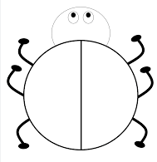

Highlight the way you worked out the missing number.

- In my head

- Number line

- Counters

- Supported by teacher or teaching assistant

Extension: Roll a dice and then aloud say the number that completes the number bonds with a partner.
10 + _____ = 10
9 + _____ = 10
8 + _____ = 10
7 + _____ = 10
6 + _____ = 10
1 + _____ = 10
5 + _____ = 10
3 + _____ = 10
4 + _____ = 10
2 + _____ = 10
0 + _____ = 10

