Circle the box with the greatest amount.
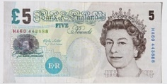 |  | 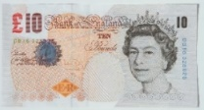 |  | 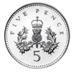  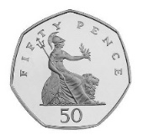 |  | 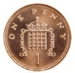  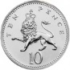
£____ £____ ____p ____p

 |  |  |  | 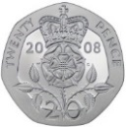 |  | 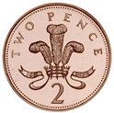
£____ £____ ____p ____p

Circle who has the least?
I have £24 I have 24p I have 38p I have £38





Use <, > = to compare the amounts.
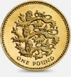
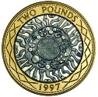

£____ £____

____p ____p

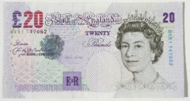

£____ £____

Four 5 pence coins are worth more than two 10 pence coins.

_{Do you agree? ____}
_{Explain why}

