Cool level
Walt: solve problems involving time
Bart leaves for football at 10 o’clock.  It takes him one hour to get there. What time does he get there?  Draw the time on the clock. |  | 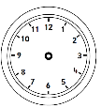
Laura goes swimming at 9 o’clock. She swims for 1 hour. What time does Laura get out of the pool?  Draw the time on the clock. | 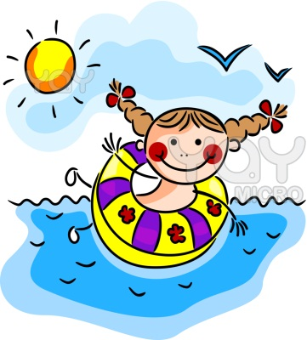
The Angry birds go to the cinema. They arrive at 3 o’clock. The film lasts one hour. What time do they leave the cinema? | 
Hello Kitty goes shopping. She goes on the bus which takes one hour. If she sets off at 11 o’clock, what time does she get there? | 
The children start dancing at 6 o’clock. They finish an hour later. What time do they finish dancing? | 

