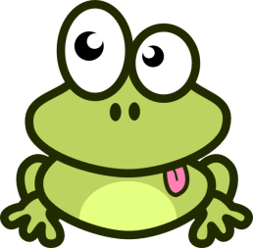
Cut out, order and label my baby photos!!

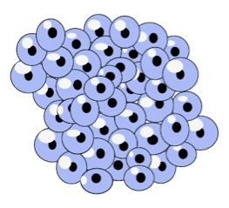
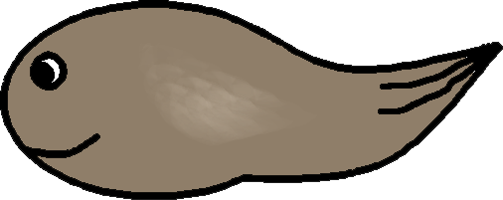

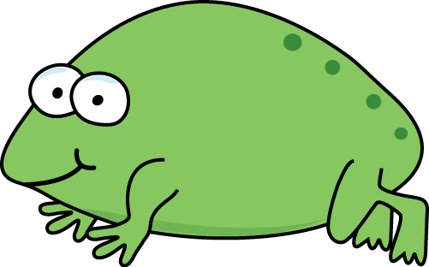
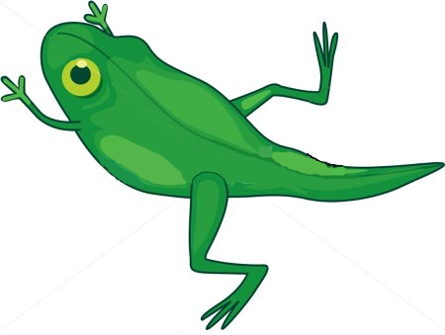
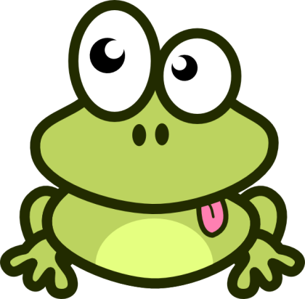

Cut out, order and label my baby photos!!
Tadpole Froglet Frogspawn Frog Tadpole with 2 legs Tadpole with 4 legs

Cut out, order and label my baby photos!!

T_ _ _ _ _ _ F_ _ _ _ _ _ F_ _ _ _ _ _ _ _ F_ _ _ T_ _ _ _ _ _ with 2 l_ _ _ T_ _ _ _ _ _ with 4 l_ _ _

