Name: ___________________ Date: ___________________
L.O. To understand how to divide by 2, 3 and 5.


Sometimes, a number won’t fit neatly into another number, and a few units are left over. We call these remainders: 21  10 = 2 r 1
Challenge 3.
Tick when completed:

Challenge 2.
Tick when completed:

Challenge 1.
Tick when completed:



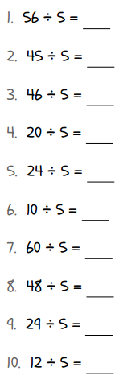
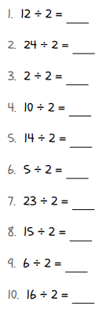
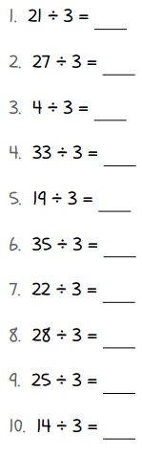
Name: ___________________ Date: ___________________
L.O. To understand how to divide by 2 and 5.
Sometimes, a number won’t fit neatly into another number, and a few units are left over. We call these remainders: 21 10 = 2 r 1
Challenge 2.
Tick when completed:

Challenge 1.
Tick when completed:






