Name: ___________________ Date: ___________________

L.O. To understand how to divide by 2, 3 and 5.
20 5 means how many 5s in 20? ___________
10 2 means how many 2s in 10? ____________



Challenge 2.
Tick when completed:

Challenge 3.
Tick when completed:

Challenge 1.
Tick when completed:

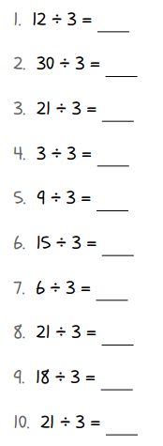
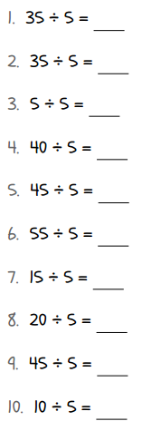
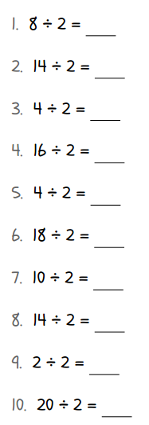
Name:___________________ Date: ___________________
L.O. To understand how to divide by 2 and 5.
20 5 means how many 5s in 20? ___________
10 2 means how many 2s in 10? ____________
Challenge 2.
Tick when completed:

Challenge 1.
Tick when completed:

Name:___________________ Date: ___________________
L.O. To understand how to divide by 2.
Can you share 2 penguins between 2 pools equally? 


Can you share 4 giraffes between 2 fields equally?


Can you share 8 parrots between 2 cages equally?


Can you share 12 zebras between 2 fields equally?

