Fantastic Mr Fox by Roald Dahl Lesson 5

Chapter 4 – The Terrible Shovels
Lesson focus – features of a newspaper report and 5W’s

Recap chapter 4. Focus on page 28 of the book. Why did the people jeer? What does jeer mean? Who else might come and look at the crater the farmers have dug? Would the police attend? Or a newspaper reporter?

Task 1 – Discuss what a newspaper report is with an adult.
Why do people read them? What types of things are written in them? Who writes news stories?

One of the people stood jeering on the hill called the local newspaper.
For the next few sessions, you will imagine that you are a reporter for that local newspaper and will write a newspaper report about what happened.

Task 2 – Read the example newspaper article on page 2 to explore the features. Use the sheet on page 3 to help you with some ideas of what to look for.

Task 3 – Use the sheet on page 3 to help you identify the features of the example newspaper report. Do not complete the sheet at this stage.

Task 4 - When writing an article, a reporter needs to include the 5Ws at the beginning of their writing. Look at the 5W’s on page 4. Discuss that the beginning of the newspaper report is meant to grab the reader’s attention and should be no longer than a couple of sentences long.

Task 5 – Write down the features of the example newspaper report using the help sheet on page 3. You can fill in the sheet, write down your answers separately or just discuss them with an adult.

Task 6 – What could the 5W’s be for an article about the farmers digging up the hill looking for Mr Fox? Use the sheet on page 4.

For example:
When - Last week; Who – three local farmers called Boggis, Bunce and Bean; What – dug a big crater with mechanical diggers; Where – in a field by the woods; Why – to capture a family of foxes.

It may be useful to read chapters 5, 6, 7 and 8 of the book before the next lesson.


Golden Girl Caught in the Act!
Woodland Press
Friday 24th April 2020
Goldilocks Granger (aged 12 ½ years) was arrested yesterday on charges of burglary and damage to property.

At approximately 9.30am yesterday morning, Nut Forest Police had a report of a disturbance at the cottage of three bears in Nut Forest and went to investigate.

When they arrived, they found three very distressed, brown bears that had suffered a terrible shock. The bears live in a lovely, quaint cottage at the edge of Nut Forest and it is well known for its beautiful garden.

They had left their home earlier in the morning, while their breakfast cooled down. Unfortunately, when they returned there was a terrible shock awaiting them. Someone had eaten Baby Bear’s porridge, broken his chair AND slept in his bed!

Baby Bear, a male, who is only 3 years old, was upset but managed to speak to reporters. He said,“My fur is still shaking from the shock, but Mummy has made me some new porridge and we are going to get nice new chair.”

Daddy Bear (a 32 year old forest worker) was too angry to speak, however we heard a lot of growling from inside the house and he is thought to have been heard threatening to eat Goldilocks if he got hold of her!

Detective Fox told us that was deeply concerned by this case and would like any witnesses to contact the police immediately.

Reporter – Mrs Prickles
“We believe that someone unlawfully broke into the cottage of the three bears and caused damage to their home. This is extremely serious. If you saw anything, please contact us immediately by phoning 999,” stated Detective Fox, Nut Forest Police.

No-one from Goldilocks’s family was available to comment on what has happened or if it was really her that did it.

A neighbour cried to reporters, saying, “Goldilocks is a sweet, kind little girl. I just can’t believe she is capable of such wickedness. Maybe they have the wrong person.”

Goldilocks will appear in court tomorrow morning to answer the charges.

If you would like to comment on this, please email us at news@WoodlandPress.com
Mrs Brenda Bear was distraught at the scene

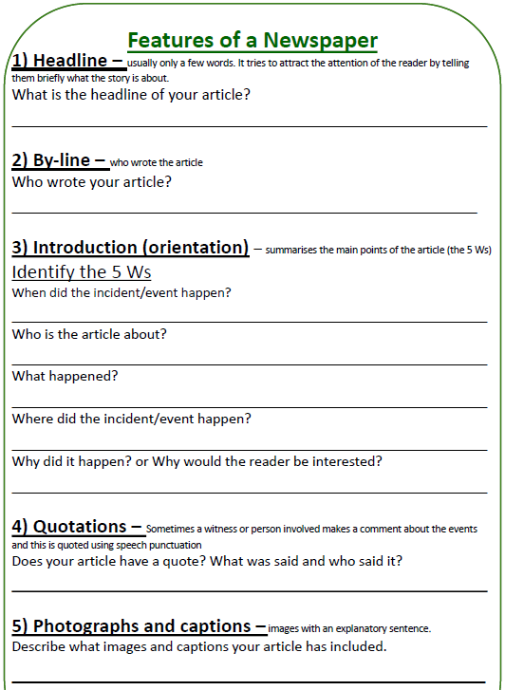
Task 3 and task 5


Task 4 and task 6

