Fantastic Mr Fox by Roald Dahl Lesson 4

Chapter 4 – The Terrible Shovels
Lesson focus – punctuate direct speech and use reporting clauses.

Task 1 – Read chapter 4 ‘The Terrible Shovels’ with an adult.
Do you agree with Mrs Fox when she states “Your father is a fantastic fox.” Do the children agree? Yes? No? Maybe? Can you share your thoughts and use evidence from the text.

How do we know a character is speaking? Remember, we use “and”, but some books only use ‘and’. In class, we called the first pair of inverted commas at the beginning of speech 66, and the pair of inverted commas marking the end of speck 99.
What other punctuation is used?
How does the author let you know who is speaking? (“Reporting clause,” whispered Miss Cook.)

Points to remember:
- “ always goes before a character speaks
- The first word of speech always begins with a capital letter
- Punctuation is always used at the end of speech to show a character has stopped speaking. This always goes before the inverted commas.
- ” to show a character has stopped speaking
- A new line for a new speaker
- Try not to use said for the reporting clause too often.

Task 2 - Look at page 2 and read the conversation between the fox family.
It shows different characters speaking using speech bubbles but when we write, we can’t use speech bubbles. We use reporting clauses to show which character is saying what. Can you remember which character is saying what?

Task 3 – Complete the task on page 3. Add the inverted commas, reporting clause (using synonyms for ‘said’) and add extra detail to the reporting clause.

Task 4 – Can you be the teacher and correct the work? Work on page 4.
If you want to correct the work further, you can change the word ‘said’, you can add extra detail to the reporting clause or add an adverb.

Task 2
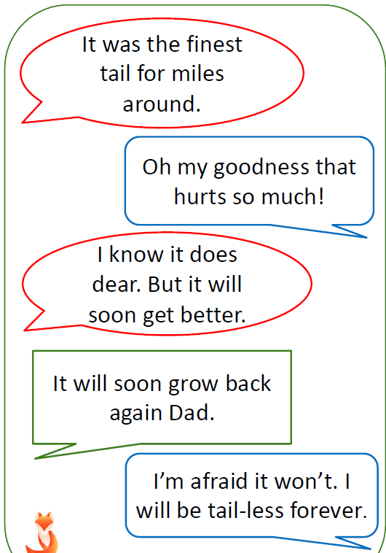

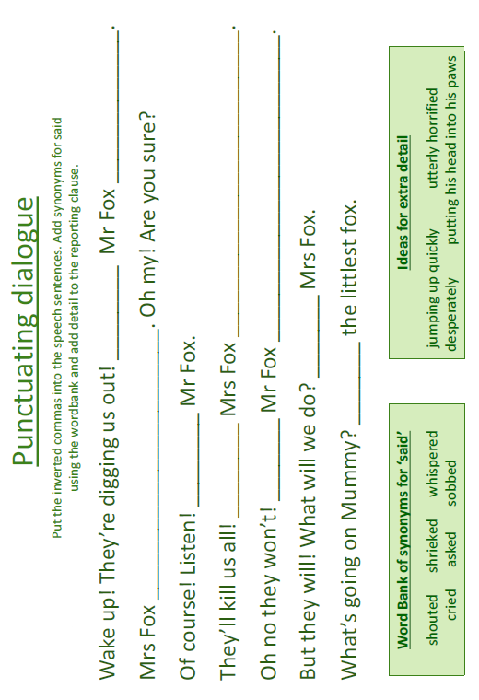
Task 3

Task 4

