Fantastic Mr Fox by Roald Dahl Lesson 3

Chapter 3 – The Shooting
Lesson focus – conjunctions to join clauses.

Recap what the story is about so far.
Task 1 - Read chapter 3 ‘The Shooting’ together with an adult.

Look at the summary of chapter 3 on the next page. Why does the writing seem disjointed? The sentences could be linked together by conjunctions. When writing, having sentences that are different lengths is more interesting for the reader.

Look at the list of conjunctions on the next page.
Which conjunctions could we use to join the two separated sentences?
For example - Mr Fox asks Mrs Fox what she would like to eat so she tells him she would like some duck for dinner.
Mrs Fox warns Mr Fox to be careful because it was getting dangerous to steal from the farmers.
Carefully, Mr Fox creeps out of his tunnel then he sniffs the air once and moves a few inches forward.

Remember, when we join two sentences together, the first full stop and
capital letter to begin the second sentence is not needed.

Also, when joining two sentences together, some of the pronouns (he) and proper nouns (Mr Fox) can be disregarded. E.g. instead of writing ‘He sniffed the air once then Mr Fox moved a few inches forward.’ Mr Fox could be disregarded to create; ‘He sniffed the air once then moved a few inches forward.’

Task 2 - On page 3 of this document, you will find conjunctions and separate sentences. Can you use an appropriate conjunction to join two of the sentences together?
There are 16 separate sentences so you should aim to try to write 8 longer sentences with a conjunction.

Task 3 – Look at page 4. What is wrong? How could it be improved?

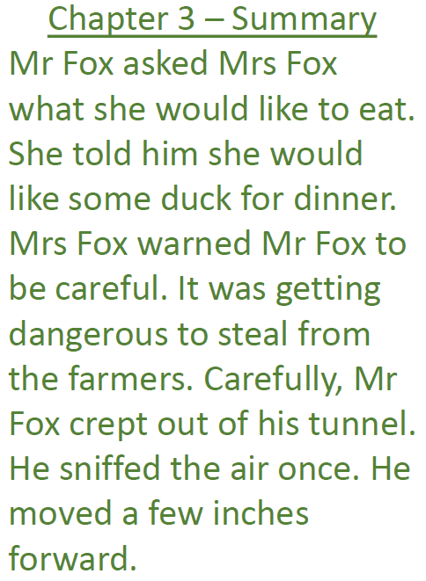
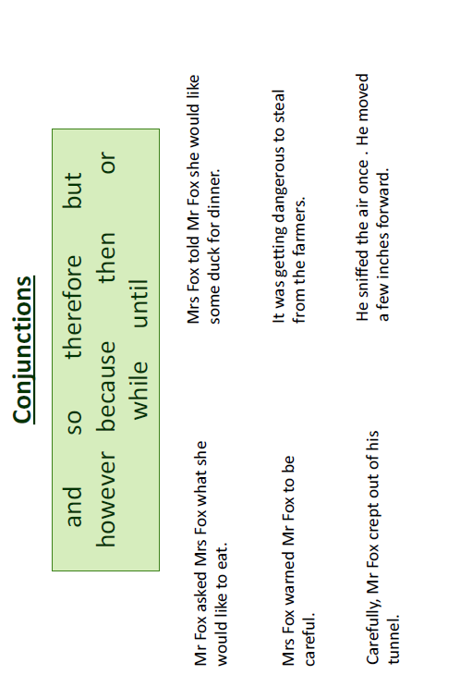

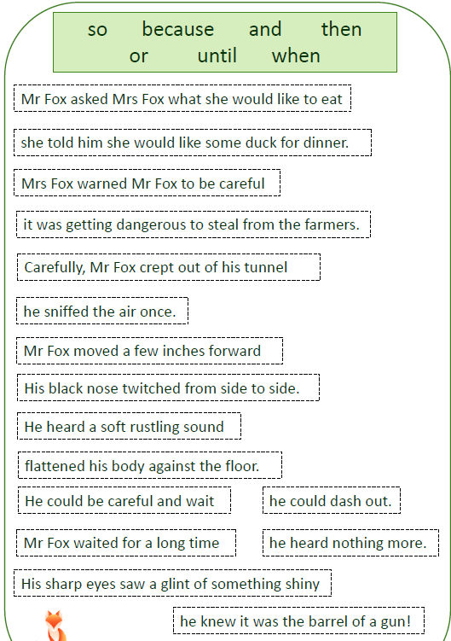
Task 2
Task 3



