Fantastic Mr Fox by Roald Dahl Lesson 2

Chapters 1 and 2
Lesson focus – describe a character.

Recap what the story is about so far.

Complete Task 1 – Sort the Adjectives. Task can be found on page 2. Discuss the meaning of the words with an adult.

Look at the answers. Do you agree with which words have been circles and which have been underlined? Could any words be for both?

Which farmer is the cleverest and comes up with the ideas to capture Mr Fox? (Bean). One of Bean’s previous ideas was to create ‘Wanted’ posters everywhere to help them capture Mr Fox but it was unsuccessful.

Task 2 – Complete a new, improved ‘Wanted’ poster to help Bean out.

A poster template, helpful word bank and an example wanted poster are included in this document. Please feel free to make your own poster template and even draw your own fox picture if you want.
Use the checklist to make sure you have included the elements to create a successful poster.

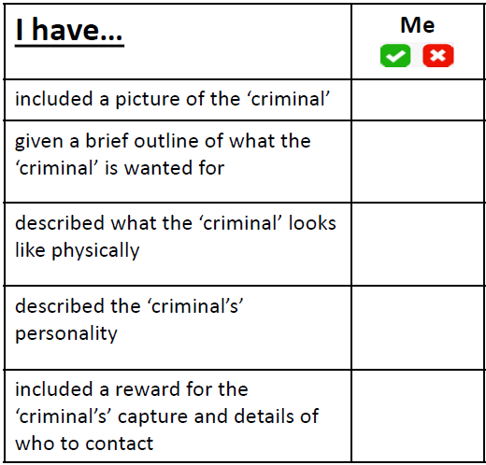

Task 1 – Sort the Adjectives

Circle the adjectives Mr Fox would think applies to him.
Underline the adjectives the farmers would use to describe Mr Fox.
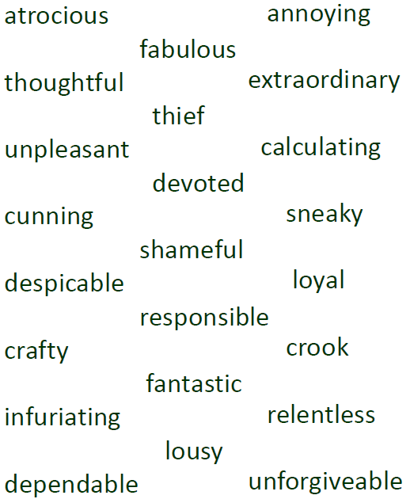

Task 1 – Sort the Adjectives ANSWERS

Circle the adjectives Mr Fox would think applies to him.
Underline the adjectives the farmers would use to describe Mr Fox.

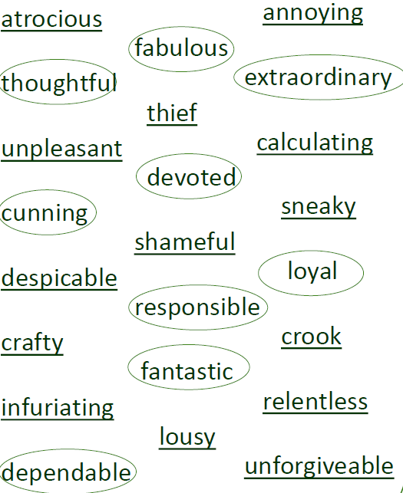

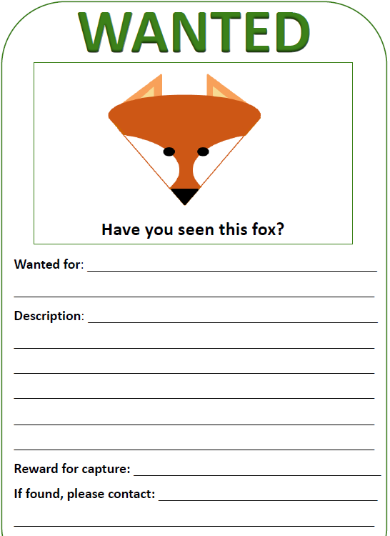
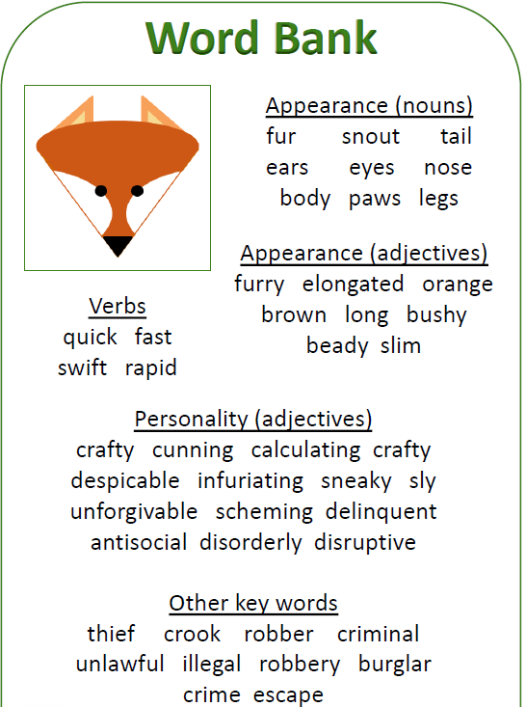

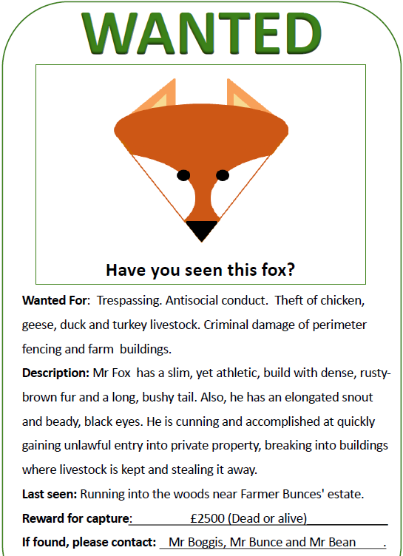
Example for ideas…

