Fantastic Mr Fox by Roald Dahl Lesson 1

Chapters 1 and 2
Today’s lesson is focused mainly around reading, discussing ideas and coming up with possible questions and answers for the main characters so far.

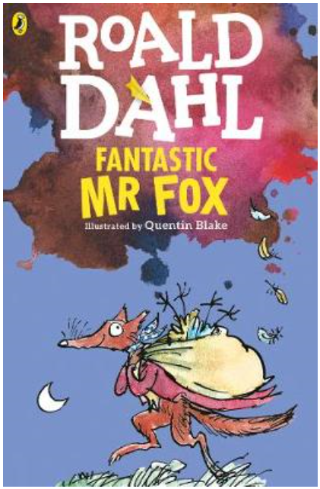
Look at the image of Mr Fox from the front cover of the book.
What does it tell you about the fox?
Is he the main character?
What is he doing?
What kind of character do you think he is from the clues in the picture?
What time of day is it?
What is in the bag?
Is he sneaking about?
Has he stolen anything?

Look at the title of the book.
How do you think Mr Fox may live up to the title ‘fantastic’?

Read the first two chapters of the book together with an adult (‘The Three Farmers’ and ‘Mr Fox’). Make note of any unfamiliar vocabulary and note down any alliteration and rhyme.

What do we find out about Mr Fox? Were your ideas from the image at the beginning of the lesson accurate? Why are the farmers so unpleasant? What do you notice about their names? Are they right to be so cross? Is Mr Fox right to steal from them?

Create some open questions to ask either Mr Fox or any of the farmers. Questions should be based on their life and their behaviour (question ideas are on the next page). Also, create some possible answers for these questions.
Work with someone at home – one of you needs to get into character as Mr Fox or one of the farmers and answer the questions, whilst the other one asks the questions. You can have a go at both roles if you wish. You could take a picture of your questions and answers and share it with me.

Why do you think Roald Dahl called them Boggis, Bunce and Bean? Could it be that together the words don’t seem pleasant, just like the characters? (You may notice that Bunce and Bean rhyme with ‘dunce’ and ‘mean’, Boggis ‘almost’ looks like the word ‘bogies’).


